MS SQL SERVER
Standard Operating Procedures
(SOP)
SQL Server 2014 Installation

Submitted to



By



CIS, Wipro Limited

Document Details

Project Name | Innogy SE
Account | CIS
IT Component/Application Title | SQL server 2014 installation document
Current Version | 1.2
List of Contributors | Pradipkumar Kansara, Kiran Bhalekar, Ayushi Gautam, Ayushi Srivastava
Customer Contact Information

Version History
(All revisions made to this document must be listed in chronological order. All revisions must be approved. Review and Approval can be done by an internal source or by the customer)
Version | Date of Revision | Description | Author | Reviewed By | Approved By
1.0 | 07-09-2017 | Initial Draft | Kiran Bhalekar | Pradipkumar Kansara | Santosh Badiger
1.1 | 08-09-2015 | Document Completed | Kiran Bhalekar | Pradipkumar Kansara | Santosh Badiger
1.2 | 18-12-2018 | Updated the document | Ayushi Srivastava | Pradipkumar Kansara | Santosh Badiger

Document Distribution List
S.No | Name and Company | Purpose
1 | RWEIT-SQLDBA | This document is about the standard procedure for SQL server 2014 installation
2

Microsoft SQL Server 2014 Installation:

Purpose of document

The purpose of this document is to describe a standard way in which to install SQL Server 2014 across RWE IT UK.
Some projects may require slight changes to accommodate the application software, but unless otherwise instructed, this is how SQL 2014 installations will be performed.

Scripts have been created to perform an unattended install (detailed at the start of this document) which should be used as standard. This document simply shows the steps that the unattended install will perform.

If servers are required to be installed with Analysis Services, Reporting Services, clustering or other special requirements, this will be covered in separate documents.

Also for the purposes of this document it is assumed that SQL Server will be the only application installed (ie: it won’t be sharing its resources with a Web Server or other application which could use a lot of resources).

Pre-requisites

Server with a minimum of:
2Gb RAM
C:\ - Logical disk partition for Operating System, Program Files.
D:\ - Logical disk partition for Pagefile and any source code.
E:\ - Separate logical disk (NOT simply a partition) for MSSQL data files. If SAN - Silver
F:\ - Separate logical disk (NOT simply a partition) for MSSQL transaction log files. If SAN - Gold
G:\ - Separate logical disk (NOT simply a partition) for database backup files. If SAN – Bronze
H:\ - For systems with high I/O requirements where the additional disks are available, use separate logical disk (NOT simply a partition) for Tempdb data files. If SAN – Gold. If installing on a standalone server where only 3 logical disks are available, Tempdb data files should go on the G drive.

For best performance internal disks should be RAID1+0 with a stripe size of 256K.
Partitions for SQL disks (ie: E, F & G) should be Basic and created with a disk alignment of 1024.
All disks (Internal or SAN) should be formatted as NTFS with an Allocation Unit Size of 64K.

Windows Server 2012 R2 SP2
Windows Installer 4.5
.Net 3.5 SP1
Screen resolution on the server should be a minimum of 1024 x 768
The C drive should have a minimum of 2Gb free space for temporary files created during install.
Remote Access should be enabled
TSM Backup
BMC Patrol
Innoculate Anti-Virus
Hyperbac 4.3.0.4 or higher NOTE: The Primary DNS Suffix must be set (this is for the Hyperbac license).

SQL 2014 Unattended Installation

The unattended installation is the preferred method of performing a SQL Server installation to ensure consistency.

Normally this would be performed by WINTELSERVER as no DBA input would be required (unless something goes wrong!) – NOTE: This is currently just proposed. Auto installs are still being tested by WINTEL so until they have signed it off, DBAs will for the time being continue to perform installs.

In order to perform an unattended install, copy the SQL2014_Install directory and sub-directories in the KFDBASE share to the D:\SOURCE directory of the target server.
Open the file D:\Source\SQL2014_Install\INI\default.ini and modify the INSTANCEID parameter to be the named instance your require (eg: MYTEST1D).

NOTE: The instance name should follow the format of a maximum of 6 characters relating to the application name followed by the instance number (1, 2, etc) followed by D for Development, T for System Test, U for UAT, E for Training, S for Production Support or P for Production.
So for example for “My Test” in Development I could call it MYTEST1D.

Save the file as the instance name, eg: MYTEST1D.ini
Open a command window and change directory to D:\Source\SQL2014_Install
Type SQL2K8INSTALL.bat plus the instance name and press enter, eg:

SQL2K8INSTALL.bat MYTEST1D

The job will then pause and you will then be reminded that the pre-requisites should have been installed and the .ini file modified as required. If this is not the case you can abort the job at this point with CTRL-C, otherwise press any key to continue.

The job will now perform a standard installation of SQL Server 2014, Service Pack 1, perform a basic configuration and install our standard Stored Procedures.

Once it has completed, check the installation log (D:\Source\SQL2014_Install\SQL2014_installation_log_YYYYMMDD.txt) for any errors and if everything is ok delete the .ini files and then reboot the server.

If there is any doubt about whether the installation was successful then further information can be found in the SQL installation logs, located at : C:\Program Files\Microsoft SQL Server\100\Setup Bootstrap\Log

For information only, the following pages show the steps taken if performing a manual installation.

SQL 2014 Manual Installation:

1. Open the Source folder where setup file is placed.

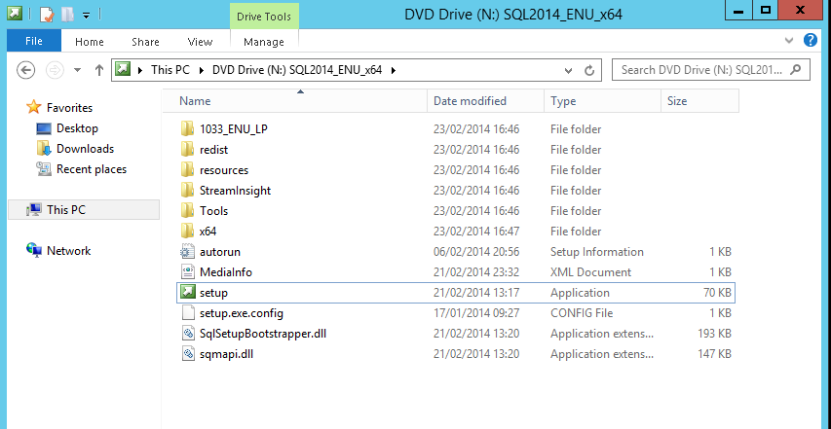

2. Click on 'setup' file then you will get following window.
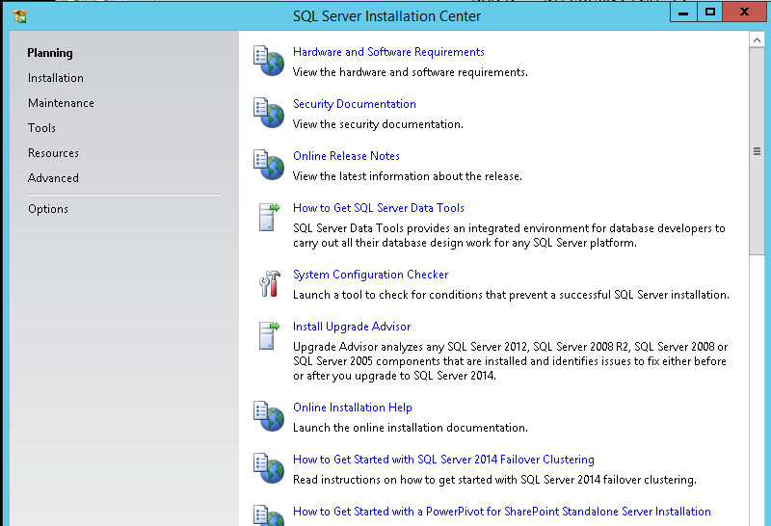

3. Click on Installation then you will get below window.
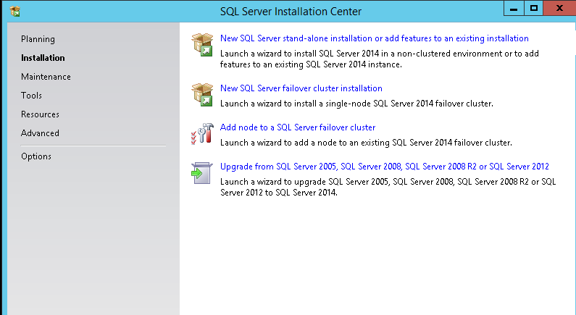

4. Click on 'New SQL server stand-alone installation or add features to an existing installation', and you will get below window.
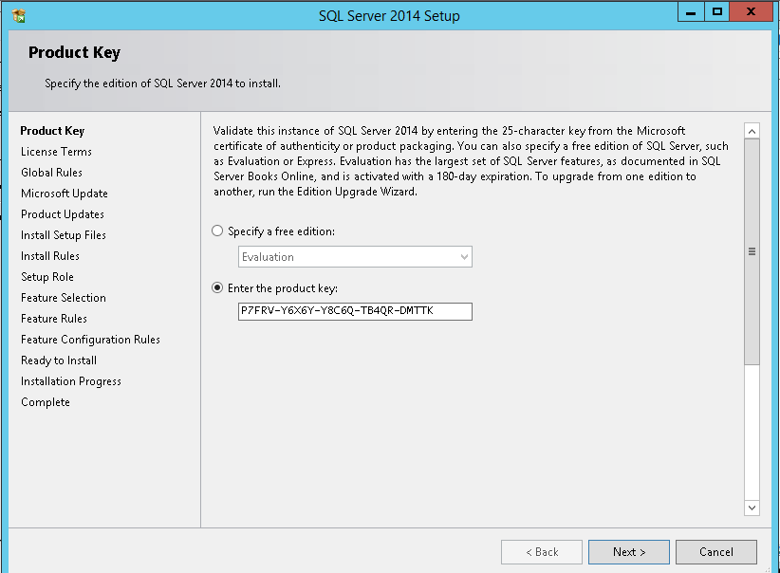
5. You have to enter the product key here and then click on 'NEXT'.

6. After clicking Next you will come to below window. Here you have to accept the terms and conditions and after that click on 'NEXT'.
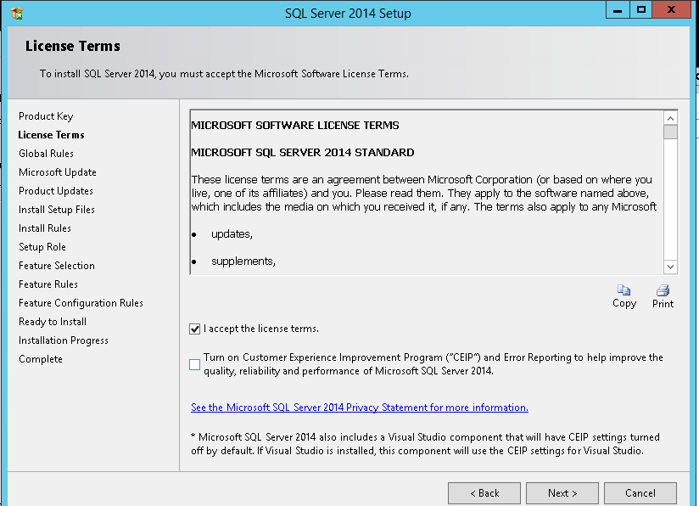
7. After clicking NEXT you will get below window.

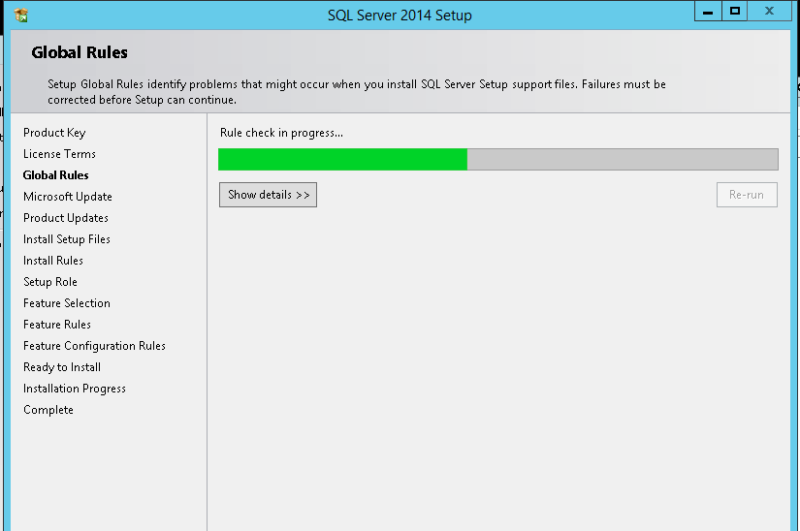
8. After checking rules, you will come to below window.
If you want any updates from Microsoft then check the checkbox but we are not going to tick this checkbox. Please click on NEXT.
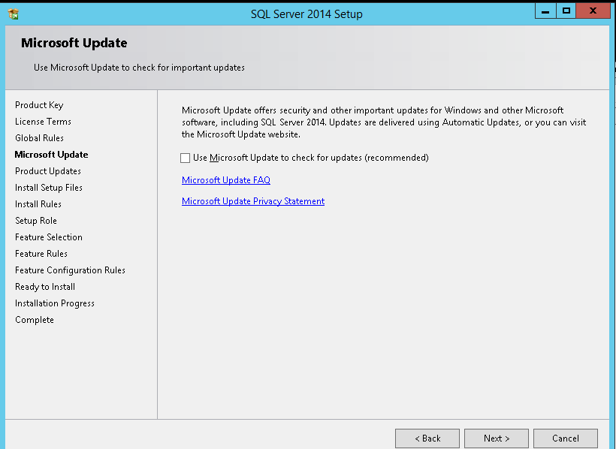

9. As we have unchecked the Microsoft update checkbox we will get the error as shown in below screenshot. Ignore this and click on NEXT.
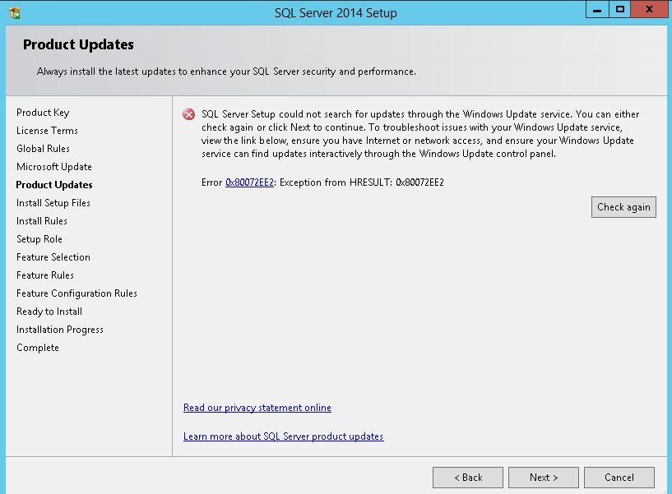
10. After clicking NEXT it will install setup files.
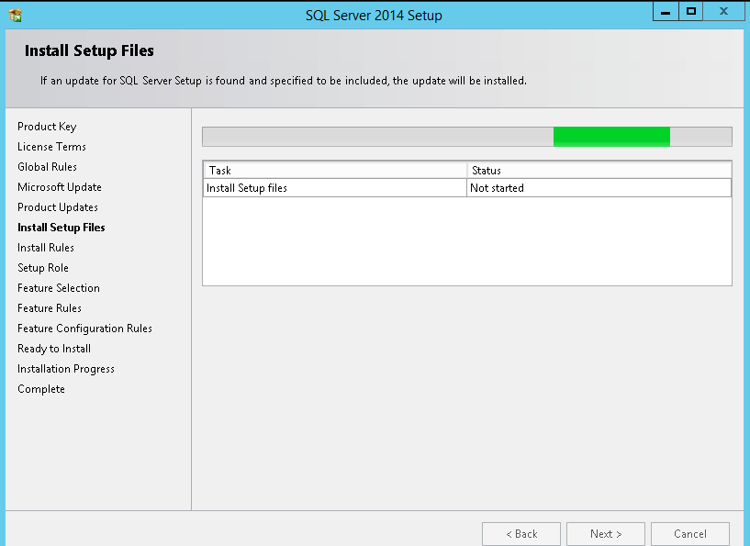
11. After installing setup files, it will check the rules and after that click on NEXT
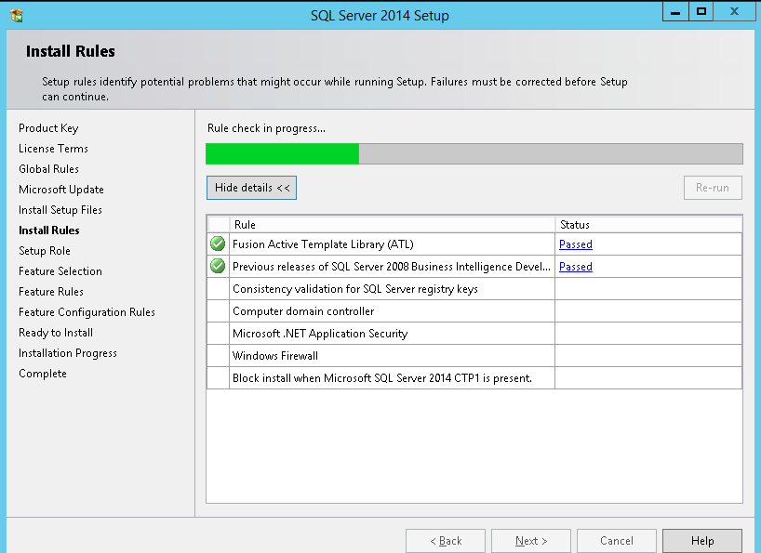

12. Click on 'SQL server feature installation' and click on NEXT.
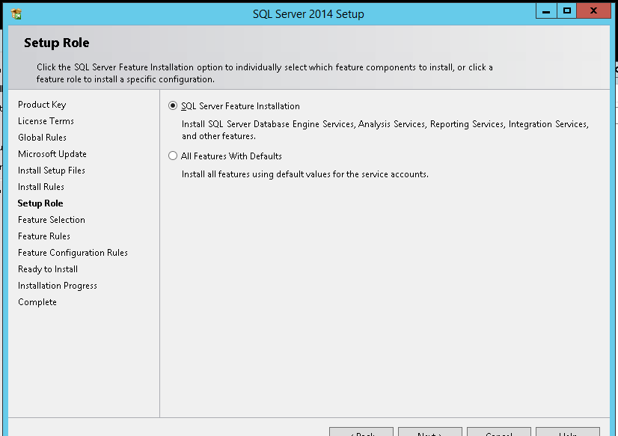
13. As per the below screenshot select the components and change the root directory to E drive. Click on NEXT.
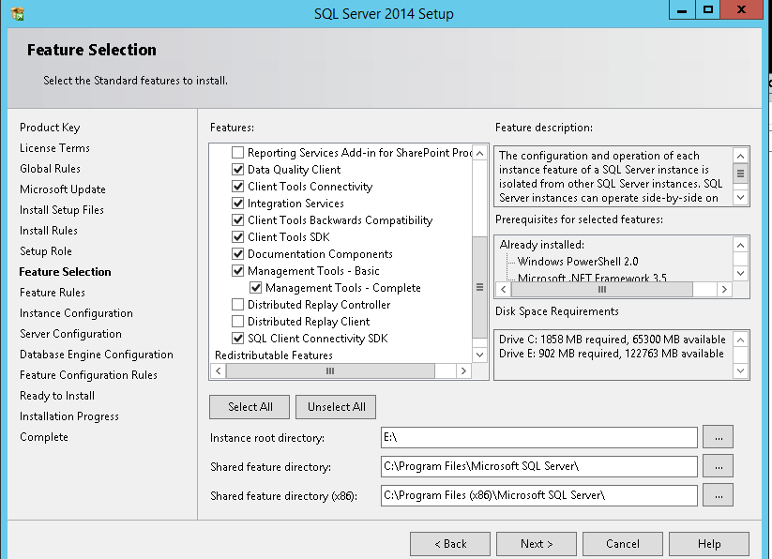

14. Here you have select whether you want named instance or default one. As per the RWE standards we have to select named instance. Type the instance name and click on NEXT.
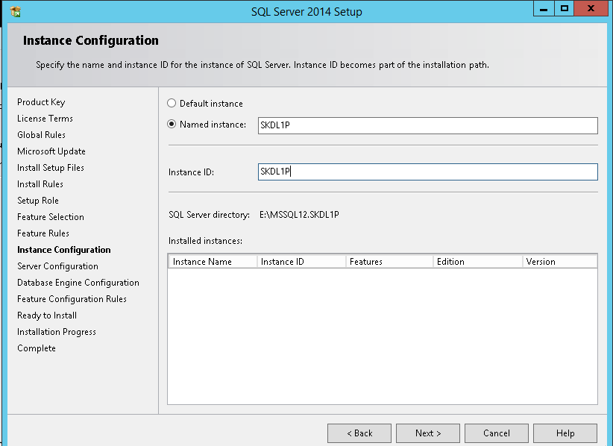

15. After clicking NEXT you will come to below window. Here you have to give service account name and password of that service account.
Remember to change startup type of SQL SERVER AGENT to AUTOMATIC.

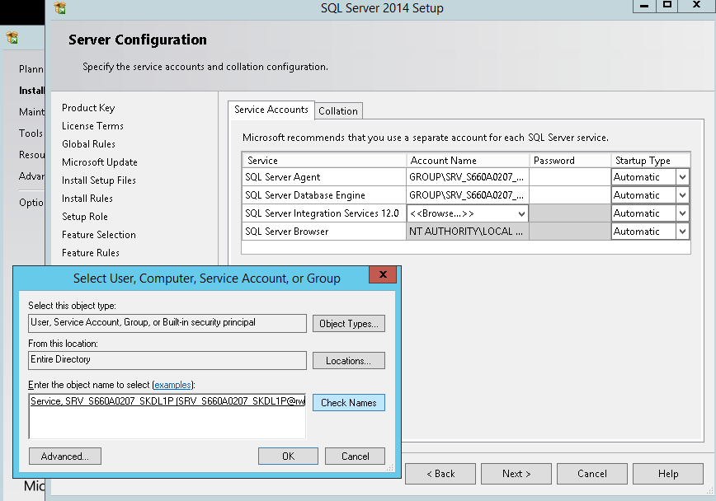

16. Select MIXED MODE here and add service account by clicking on 'Add current User'. After this click on next tab which is DATA DIRECTORIES.
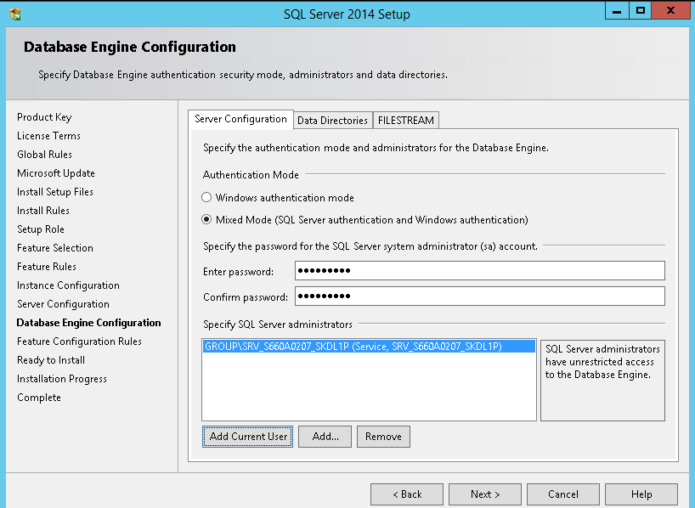

17. As per the RWE standards, please follow the directory path as per the below screenshot. and then click on NEXT.
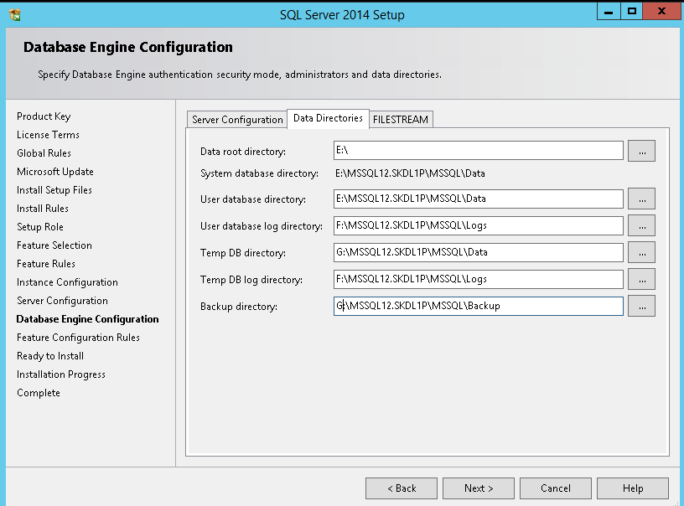
18. After clicking NEXT you will come to below window. Click on INSTALL.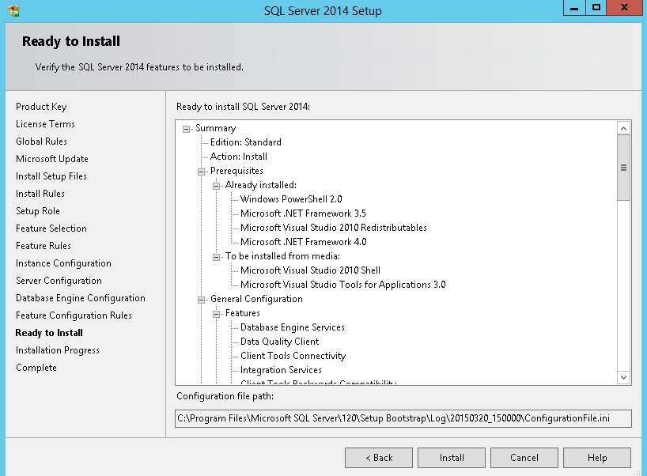

19. After installation you will get the message as success at each component whatever you have selected.

20. After installation download and apply latest patch available as per attached document.
